- IRME 3.7: A system contains 20 identical and critical components that will be replaced on failure. As a result, a constant failure rate for the system will be observed. If a design life of 10 yr with a system reliability of 0.99 is required, what should the system MTTF and median time to failure be? If each component has a CFR, what will the component MTTF and median time to failure be? Assume failure behavior of the components to be independent of each other.

- A parking lot on TAMU campus has 10 floodlights (the system) with one bulb in each floodlight (the component). The reliability of each bulb in the 10 floodlights follows the Exponential distribution with failure rate λ = 0.002 failures/day. The replacement time interval is based on the probability of 2 failures among the 10 lights. That means, the point value estimate of the probability of a bulb working at time T=t is given n/N=0/10=0.8. This is the system reliability R(t) at time t.
  - What is the Failure CDF F(t) at time t?
F(t)=1-R(t)= 1-0.8 = 0.2

  - From the expression of the exponential reliability distribution, R(t), calculate the replacement time interval in days to maintain the average number of failed bulbs at 2.

  - Identify and calculate the Binomial probability of failure event occurrence, p, based on the Binomial mean of 2 failures. The binomial mean = E(X) = pn = 2 bulb failures, where n is the total number of events or items, here n = 10 bulbs.
  - Based on the values of the Binomial parameters, p and n, write a logic expression for and calculate the probability of 2 or more bulb failures to two sd (significant digits).
Note that the Binomial distribution models the probability of one or more failure events without regard to the time of failure, whereas the Exponential distribution models the time (or length, area, volume) to the failure event, in this case, of a component or system.

- A brake component has a record of failing 125 times over an estimated 4,120,000 miles run by the vehicle in a year. It is assumed that the reliability distribution is exponential.
  - What is the estimated reliability of the component over a 12,000-mile warranty?
  - Determine the design life if a 0.9 reliability is required.
  - Find the MTTF and median time to failure
  - If one of these components is installed on each of the 4 wheel brake subsystem, what is the reliability of the automobile system over a 12,000-mile warranty? Assume a failure of any component results in system failure.
Solution:
- λ=125/4120000
R(12,000)=$e^{-\frac{12000(125)}{4120000}}=0.695$
- t_{0.90}=$-\frac{12000\left(125\right)}{4120000}(ln0.90)$=3473
- MTTF=1/λ=32960 and t_{med}=0.693(32,960) = 22,846
- λ_{system}=4λ=1.21×10⁻⁴, R(12,000)=0.2331

- Modelling failure of a household refrigerator: The time to failure of a particular refrigerator type is represented by the following pdf: f(t)=0.003(10-t)², which is valid within 0 ≤ t ≤ 10 yr, and f(t) = 0 elsewhere.
- Determine the expression for R(t), and then calculate the reliability for the first year, t = 1.
- If a 90% reliable refrigerator is required, calculate the refrigerator’s Design Life corresponding to 0.90 reliability.
- Write the expression for and obtain the failure rate function, λ(t), and state whether it is increasing or decreasing as t approaches infinity for this case.
- To evaluate the reliability of this refrigerator, write the expression for and calculate the MTTF (mean time to failure).
- Obtain the probability and thereby the % units of this refrigerator that are expected to survive its MTTF.
- The refrigerator company has a 1-month warranty program. Write the expression for and obtain the probability that the refrigerator will fail during the first month.
- Write the expression for and calculate the probability that the refrigerator will survive the 1-month warranty program. Then write the expression for and calculate the conditional probability that the refrigerator will survive the rest of the first year, given the probability that it will survive its warranty period of one month.

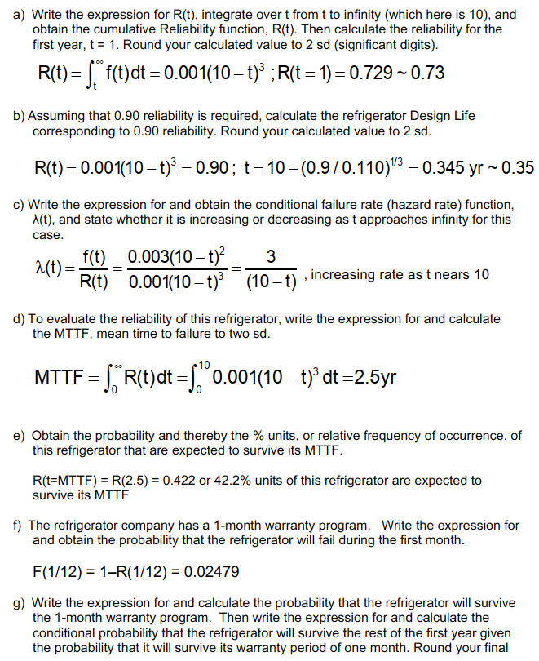
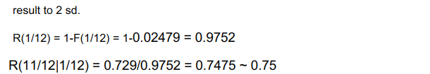

- Consider a mission-critical system made up of a component with a constant failure rate of 0.00156 per hour.
  - Find the reliability of the system at 1000 hr.
  - If the failure of this mission-critical system before the 1000 hr can cause a monetary loss of $1M, what is the risk of failure?
You decide to add a redundant component to the system. Now the mission-critical system is made up of two redundant components having constant but different failure rates, λ₁(t) and λ₂(t).
  - Derive the reliability function and the MTTF for the system.
  - Find the reliability at 1000 hr and the MTTF of the system where λ₁(t)=0.000356 per hour and λ₂(t)=0.00156 per hour.
  - If the failure of this mission-critical system before the 1000 hr can cause a monetary loss of $1M, what is the new risk of failure of the system? If addition of a redundant component costs $300,000, is it justified to add the new redundant component to the system?
- R(t)=e^{-λt}=e^{-(0.00156*1000)}=.21
- F(1000)= 1-R(t)=1-0.21=0.79
Risk= F×C=0.79×$1M=$790,000
c.
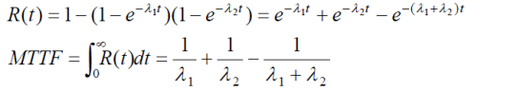
d.

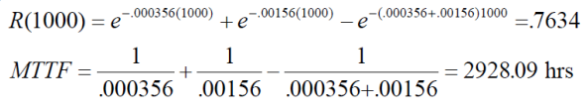
  - New risk= F×C=(1-0.76)×$1M=$240,000
Installation of new redundant component costs $300,000, but the risk is reduced by ($790,000-$240,000=) $550,000. So installation of the new component is well justified.

